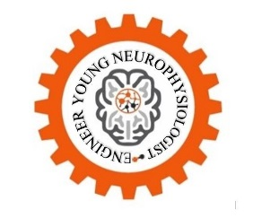
Table of course lessons
“Young neurophysiologist-engineer”

67 lessons involving theoretical material (67 lessons, laboratory work of 5 types: neurophysiology, neurophysiology and robotics, interactive workshop on neurophysiology, robotics, and laboratory work in the “polygraph” system (at least 10 tasks)).
Section 1. Introduction to neurotechnologies
Assumed hours: 6
Assumed lessons: 3
Section content
Students’ introduction to cutting-edge technologies, emerging markets and prospects for their development in the framework of career guidance, as well as getting knowledge on neurotechnologies value in the modern world. Introduction to the bioelectrical activity of the living creatures, the cause of its appearance and assessment methods on the example of photoplethysmogram.

Lesson No. | Lesson topic | Photo
1 | Introduction to neurotechnologies | 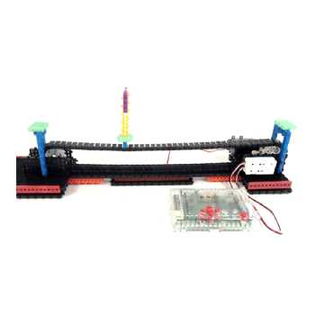
2 | Bioelectrical activity of the living creatures
3 | Simple assessment methods of human bioelectrical activity

Section 2. ECG (Electrocardiogram)
Assumed hours: 20
Assumed lessons: 10
Obtained skills set
Student:
- Introduction to the concept of the cardiac electrical axis and methods of its building
- Generation of primary knowledge of the main structural elements during the ECG description
- Conduction of heart rate analysis
- Knowledge on electrocardiogram interpretation
The student will learn:
- Physiology of cardiac activity
- Structure and principles of the heart functioning
- Human circulatory system
- The main mechanisms of the heart functioning and its electrophysiological activity

Lesson No. | Lesson topic | Photo
1 | Physiology of cardiac activity | 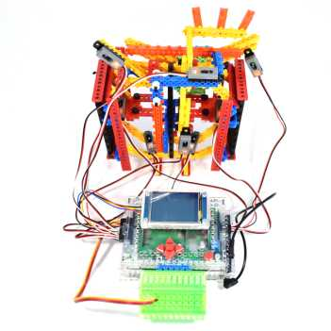
2 | Cardiac electrophysiological activity
3 | How to record an ECG. Electrodes placement
4 | The concept of “ECG leads”. How to record an ECG from leads | 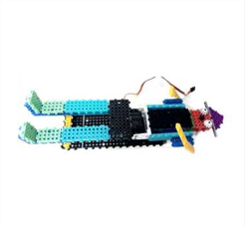
5 | The concept of the cardiac electrical axis. Building of the cardiac electrical axis. | 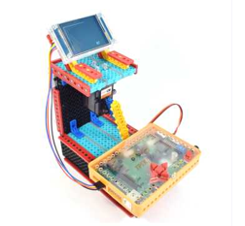
6 | Elements of normal ECG | 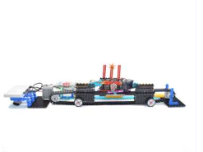
7 | ECG analysis of a healthy person. Part 1
8 | ECG analysis of a healthy person. Part 2
9 | Heart rate variability in various conditions. BFB (biofeedback) basics.
10 | Heart rate variability. Exercise ECG testing.

Section 3. EMG (Electromyography)
Assumed hours: 12
Assumed lessons: 6
Section content
The study of the human muscles types and their activity, the concept of “innervation” and muscle functioning. Introduction to the basic method of recording signals (potentials) of the human muscles. Studying the properties of the peripheral nerves conduction. Shaping the knowledge about the basic concepts of the “galvanic skin reaction”. The study of the main indicators of the skin electrical activity.
Obtained skills set
The student will learn:
- Human muscles types and their activity
- The concept of “innervation” and “muscle functioning”
- The basic method of recording signals (potentials) of the human muscles
- The properties of the peripheral nerves conduction
- The main indicators of the skin electrical activity
- The basic concepts of the “galvanic skin reaction” section:
- Skin
- Transpiration
- Psycho-emotional state of a person

Lesson No. | Lesson topic | Photo
1 | Innervation and muscle functioning
2 | EMG – methods of study
3 | Peripheral nerves conduction
4 | The concept of GSR (galvanic skin response)
5 | GSR indicators and their recording
6 | “Secret package” game

Section 4. Human brain and its functions
Assumed hours: 12
Assumed lessons: 6
Section content
The study of the structure and main functions of the brain (regions and lobes). Shaping the basic knowledge about the operation principles, functions of nerve cells (neurons) and their role in the human body work.
Obtained skills set
Student:
- Will study the structure and main functions of all brain regions.
- Will shape basic knowledge about the operation principles, functions of nerve cells (neurons) and their role in the human body work

Lesson No. | Lesson topic | Photo
1 | The structure and main functions of the human brain | 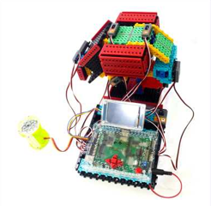
2 | Medulla oblongata | 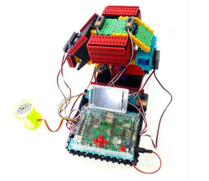
3 | Hindbrain. Pons and cerebellum | 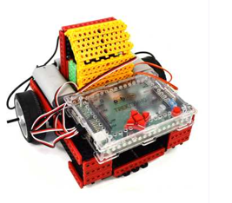
4 | Hindbrain. Mesencephalon
5 | Diencephalon | 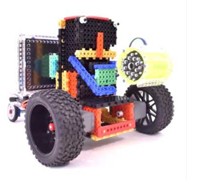
6 | Telencephalon (cerebral hemispheres)
7 | Neuron and its structure | 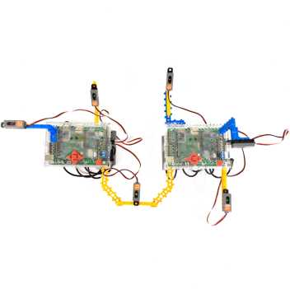

Section 5. Electrophysiological methods of brain study
Assumed hours: 2
Assumed lessons: 1
Section content
History of the neuro-and psychophysiology development. Shaping the knowledge about the main discoveries of the 20th century. Obtaining the basic skills of working with the neuro-headset. The study of the “brain electrical activity” concept. EEG study and introduction to the existing types of leads, which are used for electrodes placement systems. Study of the basic detectors (leads) placement systems for EEG recording. The study of the main brain examination methods.
Obtained skills set
The student will shape:
- The knowledge about the main discoveries of the 20th century.
- The basic skills of working with the neuro-headset
The student will study:
- History of the neuro-and psychophysiology development
- EEG and basic types of detectors (leads) placement systems for EEG recording
- The main brain examination methods
Lesson No. | Lesson topic | Photo
1 | Brain electrical activity
2 | Types of leads for EEG recording. Electrodes placement
3 | 10-20 system
4 | Main methods of brain electrical activity examination | 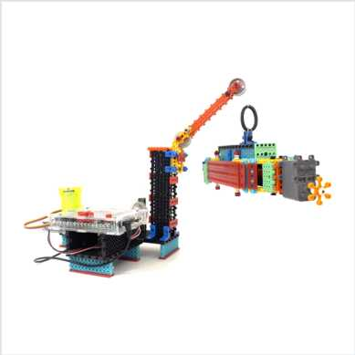

Section 6. Basic EEG rhythms, preparation for EEG recording
Assumed hours: 10
Assumed lessons: 5
Section content
The study of the modern encephalographs operation principle. Introduction to the rhythms and elements of the EEG. The study of the detection process of the EEG signals, which are not related to the brain signals. The study of the human biological rhythms and the main properties and conditions of the alpha rhythm recording.
Obtained skills set
The student will be introduced to the main biological rhythms and EEG elements.
The student will study:
- The modern encephalographs operation principle
- The detection process of the EEG signals, which are not related to the brain signals
- Human rhythms
- Main properties and conditions of the alpha rhythm recording

Lesson No. | Lesson topic | Photo
1 | EEG description. Biological rhythms. | 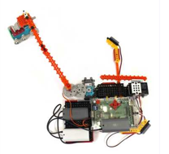
2 | Signal extraction out of noise. Artifacts | 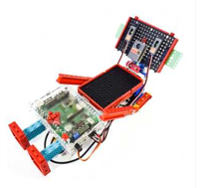
3 | Basic EEG rhythms. Part 1 – alpha-, beta-, gamma-, theta-, delta-rhythms | 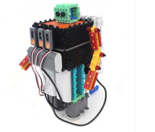
4 | Basic rhythm of resting state – alpha-rhythm

Section 7. Rhythms
Assumed hours: 12
Assumed lessons: 6
Section content
The continuation of EEG rhythms study. Shaping the basic knowledge about the human states (wakefulness, state of rest).
Obtained skills set
The student will continue to study EEG rhythms. The student will shape the basic knowledge about the human states (wakefulness, state of rest).

Lesson No. | Lesson topic | Photo
1 | Wakefulness, rest state. Open-close eyes state. | 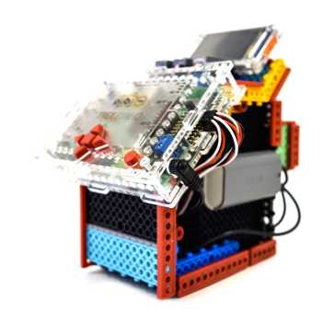
2 | Sleep | 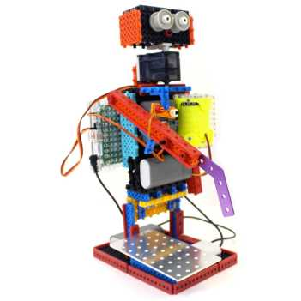
3 | Relaxation | 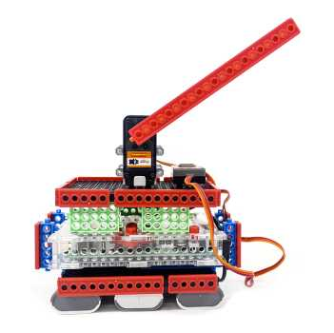
4 | Dynamic mental activity. Part 1 | 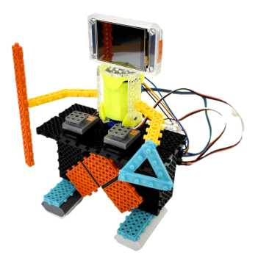
5 | Dynamic mental activity. Part 2 | 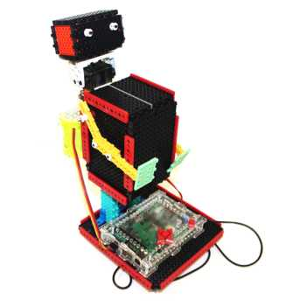

Section 8. Evoked potentials
Assumed hours: 12
Assumed lessons: 6
Section content
Shaping the knowledge about the “evoked potential” concept and the study of patterns types. The study of the main components of evoked potentials and audial P-200. The study of the evoked potentials and visual P-300. The study of the evoked potentials, mu-rhythm. The study of the evoked potentials and the component of the brain response wave - P-300 signal. Introduction to the methods of evoked potentials research for solving cognitive tasks.
Obtained skills set
The student will shape the basic knowledge about the “evoked potential” concept. The student will be introduced to the methods of evoked potentials research for solving cognitive tasks.
The student will study:
- Patterns types
- Main components of evoked potentials
- Audial P-200 and visual P-300 signals
- Mu-rhythm
Lesson No. | Lesson topic | Photo
1 | Evoked potentials. Pattern concept. Patterns types
2 | Evoked potential to visual signal
3 | Imaginary movements
4 | P-300 signal | 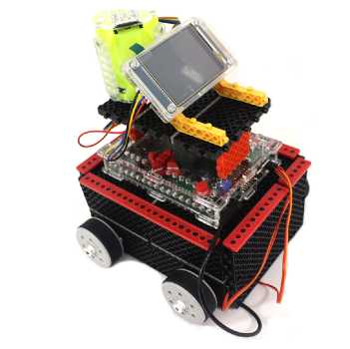
5 | Evoked potentials at cognitive tasks solving | 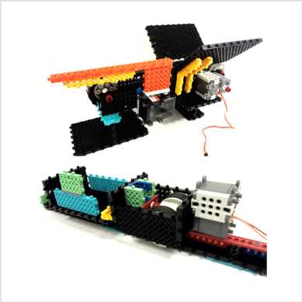

Section 9. Brain-computer interface
Assumed hours: 14
Assumed lessons: 7
Section content
Introduction to the “brain-computer interface” concept. The study of the history of its origin and development. Introduction to the basic operational principles of the wireless data transmission system. Introduction to the section of mathematical economics, studying the optimal strategies choice. The study of the history of the team games development. Shaping the knowledge about the modern areas of brain-computer interfaces development .The study of the main activities of the “engineer” group profession.
Obtained skills set

The student will be introduced to:
- “Brain-computer” interface concept
- The basic operational principles of the wireless data transmission system
- The section of mathematical economics, studying the optimal strategies choice
The student will shape the knowledge about the modern areas of brain-computer interfaces development.
The student will study:
- The history of “brain-computer” interface origin and development
- The history of the team games development
- The main activities of the “engineer” group profession
Lesson No. | Lesson topic | Photo
1 | “Brain-computer” interface
2 | Wireless data transmission system
3 | Game theory | 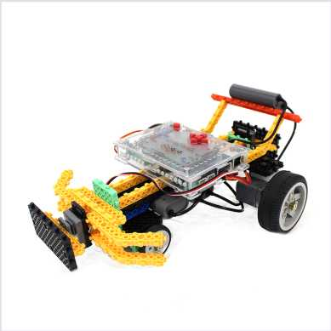
4 | Team games and sport | 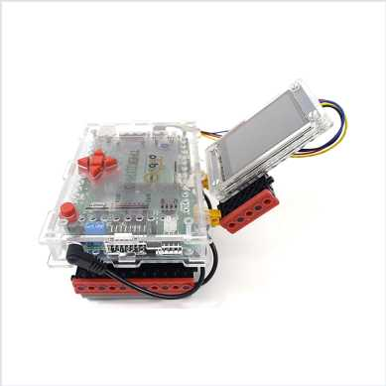
5 | Prospects for brain-computer interface development
6 | I am a human

Section 10. Neurotechnologies scope of use. Human psychophysiology
Assumed hours: 14
Assumed lessons: 7
Section content
The study of the foundations of human psychophysiology, human’s functional state. Shaping of knowledge about activity effectiveness. The study of the biofeedback (BFB) concept. BFB training in practice. Learning to record indicators in the “polygraph” mode. Laboratory works on exercise stress tests.
Obtained skills set
The student will be introduced to:
- “Exercise stress tests” concept and its application in day-to-day life
- Indicators analysis in the “polygraph” mode.
The student will study:
- the biofeedback (BFB) concept and “regulation of the human functional state”
Lesson No. | Lesson topic | Photo
1 | Basics of human psychophysiology
2 | Functional states of a human. Activity effectiveness
3 | Biofeedback (BFB) concept. Regulation of a functional state.
4 | BFB training in practice
5 | Indicators recording in the “polygraph” mode
6 | Exercise stress tests
7 | Exercise stress tests
8 | Functional breathing reserves

Section 11. Devices control
Assumed hours: 10
Assumed lessons: 5
Section content
Principles of modern devices control. Principles of virtual and augmented reality. Shaping the knowledge about the “bionics” science and the principles of control in two-dimensional and three-dimensional space. Introduction to neuroprogramming.
Lesson No. | Lesson topic | Photo
1 | Devices control principles
2 | Virtual and augmented reality
3 | Bionics and control techniques
4 | The principles of control in two-dimensional and three-dimensional space
5 | Neuroprogramming

Section 12. Career guidance
Assumed hours: 4
Assumed lessons: 2
Section content
Shaping the knowledge about the professions related to neurotechnologies, and the concept of “career guidance”. Introduction to the career guidance methods. Using the methods of self-grading, as well as testing students for the purpose of career guidance, identifying the professionally important characters using the expert system of complex personality analysis (an author’s development, a patent of Candidate of medical sciences, a professor of the department of Military psychophysiology of the Military Medical Academy named after S.M. Kirov, a doctor-psychophysiologist A. M. Biliy).

Lesson No. | Lesson topic | Photo
1 | A group of professions focused on the use of neurotechnologies based on the  example of the “neuro-technologist” profession
2 | The career guidance methods. The expert system of complex personality analysis

